Senate Meeting Minutes
21 March, 2022
Start Time: 21:0 PST
End Time: 21: PST

Agenda
- Welcome and Sign In
- Approve 3/7 Minutes
- Senate Chair Updates
- Tentative funding Request: Nobody Fails
- Room Retention Update
- Reading period Presentation from AAC
- AAA Amendment
- Open Forum

Minutes

- Call to Order
  - 21:00 PST
- Approve 3/7 Minutes
  - Motion to Approve: Michael
  - Seconded: Kimi
  - Motion Clearly Passes
- Senate Chair Updates
  - Sam Bogen (AAC)
    - Hopefully we’ll have time today for the reading presentation
    - Thanks to everyone in the committee who had a discussion about mask mandates before spring break
  - Nicole Jonassen (EAC)
    - I appreciate everyone who has been using the mask recycling boxes, one more box will be added soon, will be posted on social media
    - Currently in the process of planning earth day. Reach out to me if you want to see something specific. Current ideas are a clothing swap and giving out plants
  - Michael Gadinis (AAA)
    - No new updates
  - Kimiko Adler (CSC)
    - We’re having a fun hike clean up in the San Gabriel Hills this Friday on March 15th, if you want to come DM in the chat but flyers will be posted around campus
  - Tyler Craigwell (SLC)

- Agenda 1
  - Sofia: requesting $150 from ACMC for Canes for Nobody Fails at CMC (mutual aid club), already got $100 from Fawcett Hall
  - Michael: AAA heard this request 5 minutes ago and approved to request it in full, it’s an organization that usually doesn’t get much attention
  - Nicole: Do they have an expected number of attendance for the event?
  - Michael: around 30 people, so about 5 bucks per person
  - Kimi: motion to fund in full
  - Sam G: Seconded
  - Motion: clearly passes
- Agenda2
  - DT: we’re having a forum that ASCMC is hosting this wednesday and there’s a form you can put questions in. I know we won’t reach consensus as a campus but i know we did the ebay we could
  - DT: WASC is coming tomorrow, we got 10 years the last two times and we’re up again. It’s an open session on Wednesday, it’s not scripted so come and talk. Shoot me an email if you have questions. THe anonymous link sent out today only goes to WASC, not us
  - Someone in AAA: please ask friends to send questions through that form! It’s important
- Agenda3
  - Sam: Reading period is a day without academic instruction, we have it in the spring but we’re trying to get it in the fall
  - Sam: here are comparable schools, as you see most top colleges give their students time both in the fall and spring to study before finals
  - Sam: general consensus is that we should change this, but that’s up for discussion. This wouldn’t interfere with any instructional days and would give us a four day weekend before finals week which would be helpful
  - Cindy: Have you talked to any faculty about this
  - Sam: I’ve spoken to both Dean Rentz. Possible, yes. Feasible, yes but only way down the road, not for next year
  - Nicole: Has anyone talked to Chodosh about this? I also didn’t know it was like this
  - Sam: from what I know, no
  - Michael: What happens if you have a Pitzer or Scripps class?
  - Sam: In theory, if you had a Pomona class, you’d have those days off. But for Pomona students taking classes at CMC, you’d still have to show up to class
  - Sam G: can confirm having been in that situation last year
- Agenda4
  - Michael: This amendment makes it that identity based groups don’t go through budget committees. Identity based groups are described at the discretion of the VPCO
  - Desmond: I think 9/10 of the affinity groups have requested exemption from the budget freeze and have been approved so that wouldn't be a high burden to appeal. Not all clubs have also requested this because they don’t need it, otherwise money will be sitting there. I discourage this amendment but understand why it’s being proposed
  - Nicole: how much money would it keep unused in those accounts?
  - Desmond: it depends (does some math)
  - Jon Joey:
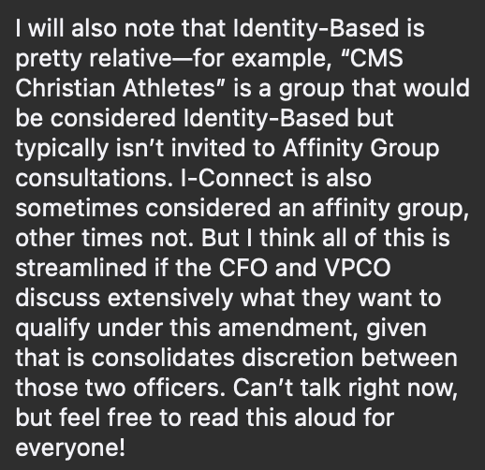
  - Michael: AAA recommendation is that senate should approve this amendment. It’s true that identity groups do get exemptions, but it's still another barrier they have to go through, especially for a student government that historically used their position to not serve the interest of everyone, this is just a way to codify our support. Especially since this is a lot of unpaid emotional labor. You don’t know what may come up, so we thought this should be passed
  - Nicole: is there a way to motion to approve with the stipulation that enumerates affinity groups which this applies to
  - Michael: There is, I’ve talked to Josh about this amendment. The reason why that wasn’t chosen is because new groups can be chartered and that would require a constitutional amendment
  - Nicole: I’m trying to find a way to accommodate the point that JJ brought up
  - Kimi: motion to approve the amendment as is, I’ll just throw that out there
  - Kaitlyn: seconded
  - JJ: currently there’s no standardized groups of affinity groups
  - Nicole: can I motion to pass this with the stipulation that all the groups that you want to be covered under this ament submit an application to the VPO that they understand this applies to them, idk if I can do that
  - Kimi: Seconded
  - Lilly: maybe instead the VPCO can make a list of groups that this applies to and senate approves of that list
  - Nicole: I’d be willing to amend my motion to that
  - Desmond: my concern is that these solutions are all more difficult than emailing me to be approved for being exempt from budget freeze
  - Cindy: whichever motion gets the most votes will pass, not the last motion
  - Cindy: motion to pass the amendment as is. 4-1-3 is the final vote
  - Motion clearly passes
  - Cindy: motion with the stipulation that the VPO creates a list that will be approved by senate. 10-0-0 is the final vote
  - Motion clearly passes
- Open Forum

- Motion to adjourn: Sam
  - Seconded: Kimi
  - Motion clearly passes
- Meeting adjourned at: 21:52

